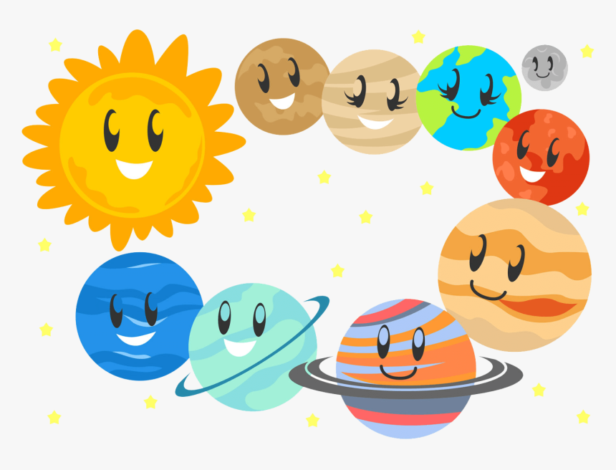
August
Sunday | Monday | Tuesday | Wednesday | Thursday | Friday | Saturday
1 | 2 | 3  Water  Play | 4 | 5  Water  Play | 6  Camp  Shirt  Day! | 7
8 | 9 | 10  Water  Play | 11 | 12  Water  Play | 13  Camp  Shirt  Day! | 14
15 | 16 | 17  Water  Play  Kona Ice Truck 10 a.m | 18 | 19  Water  Play | 20  Camp  Shirt  Day! | 21
22 | 23 | 24  Water  Play  DJ Shawn Dance Party 10-11 a.m | 25  Last Day  Of Summer  Camp | 26  UPCCC  CLOSED  Staff In-Service | 27  UPCCC  CLOSED  Staff In-Service | 28
29 | 30  First  Day of School! | 31

