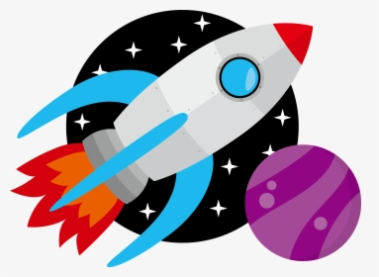
July
Sunday | Monday | Tuesday | Wednesday | Thursday | Friday | Saturday
 |  |  |  | 1 | 2 | 3
4  Happy  4th  Of  July! | 5  UPCCC  CLOSED | 6  Water  Play | 7 | 8  Water  Play | 9  Camp  Shirt  Day! | 10
11 | 12 | 13  Water  Play  Pastor Gerhart  Inspirational Chalk Demo @ 10 a.m | 14 | 15  Water  Play | 16  Camp  Shirt  Day! | 17
18 | 19 | 20  Water  Play | 21 | 22  Water  Play | 23  Camp  Shirt  Day! | 24
25 | 26 | 27  Water  Play  Bill Wood Storyteller  10:45 a.m | 28 | 29  Water  Play | 30  Camp  Shirt  Day! | 31

